**1. User Requirement Specification**

**1.1 Admin Requirement**

Admin is a person who manage all information of users, include librarians and borrowers. To use admin functions, admin don't need to log in the system.

These are some functions admin can use:

• Search accounts

• Change PIN

• Add accounts

• Update accounts

• Remove accounts

**1.2 Librarian Requirement**

Librarian is a person who manage information of books. Librarian can also view borrower information. To use all functions, librarian must check in the system.

These are some functions librarian can use:

• Add books

• Update books

• Remove books

• Search books

• View borrowers

**1.3 Borrower Requirement**

Borrower is a person who go to the library and borrow books. To use functions, librarian must check in the system. When returning books, borrowers don't need to check in.

These are some functions borrower can use:

• Borrow books

• View books

• Return books

## External Interface Requirements

* + 1. **Overview**

System Specification :

* This system used to be managed by librarian in education environment.
* This system is connected to the external display device beside PC.(such as LCD display, light display, sound display…)
* 2 main target using the system is librarian and customer(user) with two different purpose.
  + 1. **User Interfaces**
* Main target : Librarian
* Purpose: Librarian can manipulate from these to manage all information of books and customer.
* Device : PC application
* Input / Output :
  + Get data from database then perform the operation to PIC.
  + Get data from PIC then modified data to database.
  + Get data from database then show it to librarian.

### Hardware Interfaces

* Main target : customer(user)
* Purpose: customer can choose one of these action : add book to cart or return book.
* Device : LCD display
* Input / Output :
  + Get data from PIC
  + Send chosen to PIC

### Software Interfaces

### Communications Interfaces

**2.3 List of Use Case**

**2.3.1 <Admin>Overview Use Case**

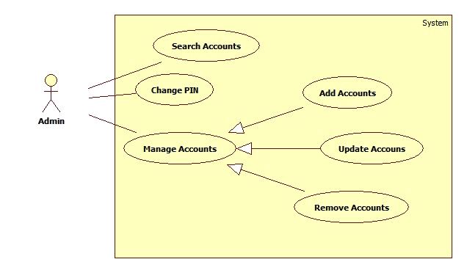

**Figure 1: <Admin> Overview Use Case**

**2.3.1.1 <Admin> Search Accounts**

**Use Case Diagram**

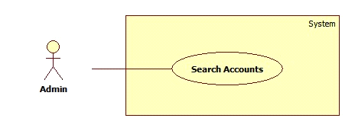

**Figure 2: <Admin> Search Accounts**

**Use Case Specification**

|  |  |  |  |
| --- | --- | --- | --- |
| **USE CASE – LAR01** | | | |
| **Use Case No.** | LAR01 | **Use Case Version** | 1.0 |
| **Use Case Name** | Search Accounts | | |
| **Author** | DuatTN | | |
| **Date** | 30/01/2015 | **Priority** | Normal |
| **Actor:**  - Admin  **Summary:**  - This use case allows admin to search for accounts of librarians and borrowers.  **Goal:**  - Search result is displayed.  **Triggers:**  - On the main screen, admin click the Search button.  **Preconditions:**  - User must be admin.  - Main page is displayed.  **Post Conditions:**   * Success: display result screen, found or not found users. * Fail: can't display the result screen.   **Main Success Scenario:**   |  |  |  | | --- | --- | --- | | Step | Actor Action | System Response | | 1 | Go to Main page | Main page is displayed | | 2 | Admin type user name in the textbox then click Search button | Display result screen | |  |  |  |   **Alternative Scenario:**  **N/A**  **Exceptions:**   |  |  |  | | --- | --- | --- | | No | Actor Action | System Response | | 1 |  |  | |  |  |  | |  |  |  |   **Relationships:** Mối quan hệ với các Use case khác nếu có trong quá trình xử lý, tuy nhiên nó không phải là abstract usecase  **Business Rules:**  - Thành phần mô tả các yêu cầu về mặt nghiệp vụ của use case.  - Tất cả các giả định về nghiệp vụ nếu có phải được ghi vào  - Chú ý tới sự chuyển đổi về trạng thái của dữ liệu cũng phải được ghi tại đây  - Các định nghĩa cũng cần làm rõ (sản phẩm nổi bật, sản phẩm sắp có là sản phẩm thế nào trong hệ thống)  - Các ràng buộc dữ liệu dưới hệ thống, các rule liên quan đến toàn vẹn dữ liệu  - Các qui trình, activities, quá trình chuyển đổi trạng thái của hệ thống | | | |

**2.3.1.2 <Admin> Manage Accounts**

**Use Case Diagram**

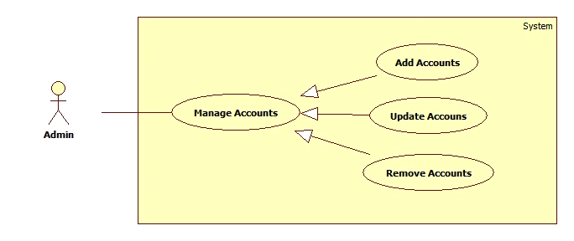

**Figure 2: <Admin> Manage Accounts**

**2.3.1.2.1 <Admin> Add Accounts**

**Use Case Diagram**

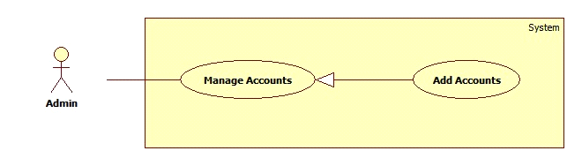

**Figure 2: <Admin> Add Accounts**

**Use Case Specification**

|  |  |  |  |
| --- | --- | --- | --- |
| **USE CASE – LAR02** | | | |
| **Use Case No.** | LAR02 | **Use Case Version** | 1.0 |
| **Use Case Name** | Add Accounts | | |
| **Author** | DuatTN | | |
| **Date** | 30/01/2015 | **Priority** | High |
| **Actor:**  - Admin  **Summary:**  - This use case allows admin to add new user accounts.  **Goal:**  - Admins add a new account successfully.  **Triggers:**  - On the main screen, admin click “Add New Book” button.  **Preconditions:**  - User must be admin.  - Main page is displayed.  **Post Conditions:**   * Success: new account will be added to database and the screen will notify that adding is successful. * Fail: new account won't be added to database and the screen will notify errors.   **Main Success Scenario:**   |  |  |  | | --- | --- | --- | | Step | Actor Action | System Response | | 1 | Go to Main screen | Display main screen | | 2 | Click “Add New Account” | Display “Add New Account” form | | 3 | Admin input all information of new Account then click Submit button | Book will be added to database and the screen will notify the result of adding new account | |  |  |  |   **Alternative Scenario:**  **N/A**  **Exceptions:**   |  |  |  | | --- | --- | --- | | No | Actor Action | System Response | | 1 |  |  | |  |  |  | |  |  |  |   **Relationships:** Mối quan hệ với các Use case khác nếu có trong quá trình xử lý, tuy nhiên nó không phải là abstract usecase  **Business Rules:**  - Books do not exist in database. | | | |

**2.3.1.2.2 <Admin> Update Accounts**

**Use Case Diagram**

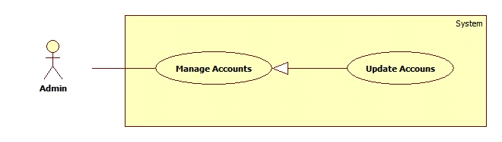

**Figure 2: <Admin> Update Accounts**

**Use Case Specification**

|  |  |  |  |
| --- | --- | --- | --- |
| **USE CASE – LAR03** | | | |
| **Use Case No.** | LAR03 | **Use Case Version** | 1.0 |
| **Use Case Name** | Update Accounts | | |
| **Author** | DuatTN | | |
| **Date** | 30/01/2015 | **Priority** | Normal |
| **Actor:**  - Admin  **Summary:**  - This use case allows admin to update information of user accounts.  **Goal:**  - Information of users will be updated to database.  **Triggers:**  - On the main screen, admin click “Update Account” button.  **Preconditions:**  - User must be admin.  - Main screen is displayed.  **Post Conditions:**   * Success: information of account will be updated to database and the screen will notify that updating is successful. * Fail: information of account won’t be changed and the screen will notify errors.   **Main Success Scenario:**   |  |  |  | | --- | --- | --- | | Step | Actor Action | System Response | | 1 | Go to Main screen | Display main screen | | 2 | Click “Update Account” | Display “Update Account” form | | 3 | User input new information of account then click Submit button | Information will be updated to database and the screen will notify result | |  |  |  |   **Alternative Scenario:**  **N/A**  **Exceptions:**   |  |  |  | | --- | --- | --- | | No | Actor Action | System Response | | 1 |  |  | |  |  |  | |  |  |  |   **Relationships:** Mối quan hệ với các Use case khác nếu có trong quá trình xử lý, tuy nhiên nó không phải là abstract usecase  **Business Rules:**  - Thành phần mô tả các yêu cầu về mặt nghiệp vụ của use case.  - Tất cả các giả định về nghiệp vụ nếu có phải được ghi vào  - Chú ý tới sự chuyển đổi về trạng thái của dữ liệu cũng phải được ghi tại đây  - Các định nghĩa cũng cần làm rõ (sản phẩm nổi bật, sản phẩm sắp có là sản phẩm thế nào trong hệ thống)  - Các ràng buộc dữ liệu dưới hệ thống, các rule liên quan đến toàn vẹn dữ liệu  - Các qui trình, activities, quá trình chuyển đổi trạng thái của hệ thống | | | |

**2.3.1.2.3 <Admin> Remove Accounts**

**Use Case Diagram**

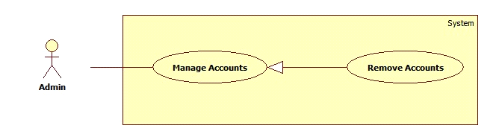

**Figure 2: <Admin> Remove Accounts**

**Use Case Specification**

|  |  |  |  |
| --- | --- | --- | --- |
| **USE CASE – LAR04** | | | |
| **Use Case No.** | LAR04 | **Use Case Version** | 1.0 |
| **Use Case Name** | Remove Accounts | | |
| **Author** | DuatTN | | |
| **Date** | 30/01/2015 | **Priority** | Normal |
| **Actor:**  - Admin  **Summary:**  - This use case allows admin to remove accounts.  **Goal:**  - Account will be removed from database and not exist in system.  **Triggers:**  - On the View Accounts List screen, admin select accounts and click “Remove” button.  **Preconditions:**  - User must be admin  - List of accounts is displayed.  **Post Conditions:**   * Success: accounts will be removed from the database and the screen will notify that removing is successful. * Fail: accounts cannot remove and the screen will notify errors.   **Main Success Scenario:**   |  |  |  | | --- | --- | --- | | Step | Actor Action | System Response | | 1 | Go to View Accounts List screen | Show list of accounts | | 2 | User select accounts then click “Remove” button | Account will be removed from database and screen will show result | |  |  |  |   **Alternative Scenario:**  **N/A**  **Exceptions:**   |  |  |  | | --- | --- | --- | | No | Actor Action | System | | 1 |  | Response | |  |  |  | |  |  |  |   **Relationships:** Mối quan hệ với các Use case khác nếu có trong quá trình xử lý, tuy nhiên nó không phải là abstract usecase  **Business Rules:**  - Thành phần mô tả các yêu cầu về mặt nghiệp vụ của use case.  - Tất cả các giả định về nghiệp vụ nếu có phải được ghi vào  - Chú ý tới sự chuyển đổi về trạng thái của dữ liệu cũng phải được ghi tại đây  - Các định nghĩa cũng cần làm rõ (sản phẩm nổi bật, sản phẩm sắp có là sản phẩm thế nào trong hệ thống)  - Các ràng buộc dữ liệu dưới hệ thống, các rule liên quan đến toàn vẹn dữ liệu  - Các qui trình, activities, quá trình chuyển đổi trạng thái của hệ thống | | | |

**2.3.1.3 <Admin> Change PIN numbers**

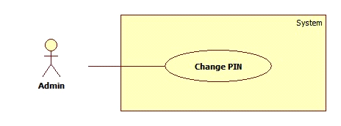

**Figure 2: <Admin> Change PIN**

**Use Case Specification**

|  |  |  |  |
| --- | --- | --- | --- |
| **USE CASE – LAR05** | | | |
| **Use Case No.** | LAR05 | **Use Case Version** | 1.0 |
| **Use Case Name** | View Student Information | | |
| **Author** | DuatTN | | |
| **Data** | 30/01/2015 | **Priority** | Normal |
| **Actor:**  - Admin  **Summary:**  - This use case allows admin to change PIN of librarians and borrowers  **Goal:**  - PIN will be changed.  **Triggers:**  - On the Main Screen, admin click Change PIN button.  **Preconditions:**  - User must be admin.  - Main Screen is displayed.  **Post Conditions:**   * Success: PIN will be changed and the screen will notify that changing is successful. * Fail: PIN won't be changed and the screen will notify errors.   **Main Success Scenario:**   |  |  |  | | --- | --- | --- | | Step | Actor Action | System Response | | 1 | Go to Main Screen | Display Main Scree | | 2  3 | Admin click Change PIN button  Change new PIN then click Submit button | Display Change PIN form  Display result screen |   **Alternative Scenario:**  **N/A**  **Exceptions:**   |  |  |  | | --- | --- | --- | | No | Actor Action | System | | 1 |  | Response | |  |  |  | |  |  |  | | | | |

**2.3.1<Librarians>OverviewUseCase**

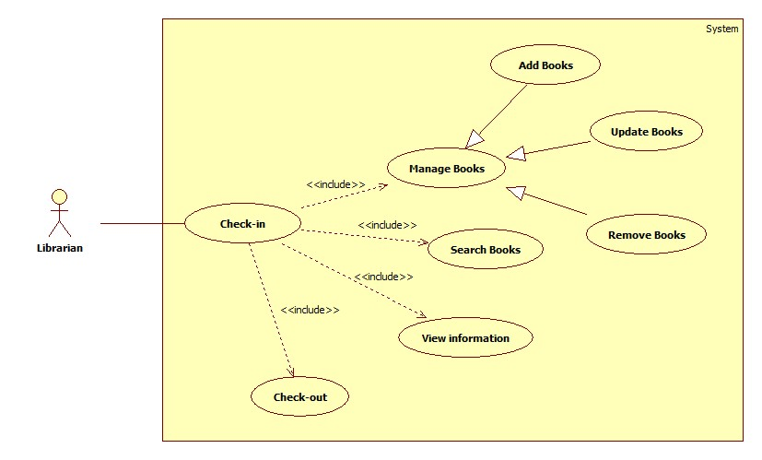

**Figure 1: <Librarians> Overview Use Case**

**2.3.1.1<Librarians>Staff check-in**

**Use CaseDiagram**

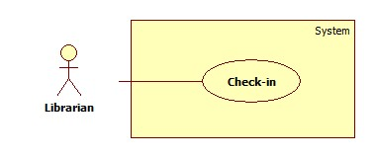

**Figure 2: <Librarian> Staff check-in**

**Use Case Specification**

|  |  |  |  |
| --- | --- | --- | --- |
| **USE CASE– LAR01** | | | |
| **Use Case No.** | LAR01 | **Use Case Version** | 2.0 |
| **Use Case Name** | Staff Check-in | | |
| **Author** | ThienTT | | |
| **Date** | 24/01/2015 | **Priority** | High |
| **Actor:**  - Librarian  **Summary:**  - This use case allows librarian to check-in the system.  **Goal:**  - Librarians login successful.  **Triggers:**  - At the login page, user scan the card with the distance is 3cm.  **Preconditions:**  - User must be librarian.  - Login page is display.  **PostConditions:**   * Success: Login is successful. * Fail: Login fail and require user scan the card or input PIN again.   **Main Success Scenario:**   |  |  |  | | --- | --- | --- | | Step | Actor Action | System Response | | 1 | Go to Login page | Login page is display | | 2 | Scan the card with distance is 3cm | Authentication page is display | | 3 | User input PIN and click Submit | Display screen of librarian works |   **Alternative Scenario:**  **N/A**  **Exceptions:**   |  |  |  | | --- | --- | --- | | No | Actor Action | System | | 1 |  | Response | |  |  |  | |  |  |  |   **Relationships:**Mốiquanhệvớicác Usecasekhácnếucótrongquátrìnhxửlý,tuynhiênnókhôngphảilà abstract usecase  **Business Rules:**  - Thànhphầnmôtảcácyêucầuvềmặtnghiệpvụcủa use case.  - Tấtcảcácgiảđịnhvềnghiệpvụnếucóphảiđượcghivào  - Chúýtớisựchuyểnđổivềtrạngtháicủadữliệucũngphảiđượcghitạiđây  - Cácđịnhnghĩacũngcầnlàmrõ (sảnphẩmnổibật,sảnphẩmsắpcólàsảnphẩmthếnàotronghệthống)  - Cácràngbuộcdữliệudướihệthống, cácrule liênquanđếntoànvẹndữliệu  - Cácqui trình,activities,quátrìnhchuyểnđổitrạngtháicủahệthống | | | |

**2.3.1.2 <Librarians> Manage Books**

**Use CaseDiagram**

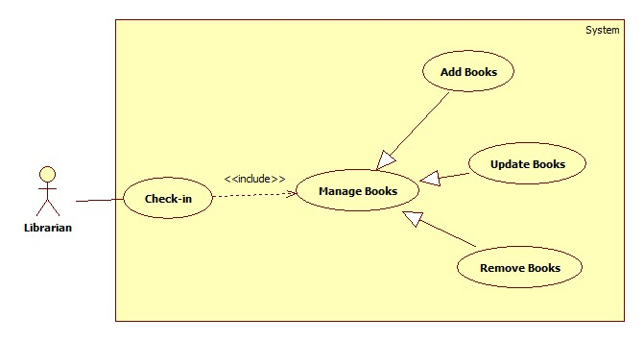

**Figure 2: <Librarian> Manage Books**

**2.3.1.2.1 <Librarian> Add books**

**Use CaseDiagram**

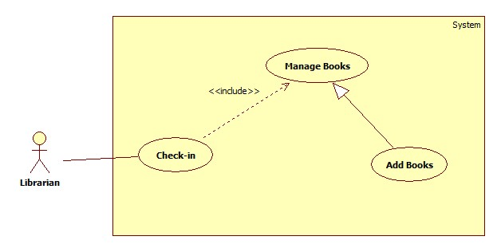

**Figure 2: <Librarian> Add Books**

**Use Case Specification**

|  |  |  |  |
| --- | --- | --- | --- |
| **USE CASE– LAR02** | | | |
| **Use Case No.** | LAR02 | **Use Case Version** | 2.0 |
| **Use Case Name** | Add New Books | | |
| **Author** | ThienTT | | |
| **Date** | 24/01/2015 | **Priority** | High |
| **Actor:**  - Librarian  **Summary:**  - This use case allows librarianadd new books to database.  **Goal:**  - Librariansadda new book successful.  **Triggers:**  - At the screen of librarian works, user click “Add New Book” button.  **Preconditions:**  - User must be login to system with role Librarian.  - Display screen of librarian works.  - User chooses Add Book function.  **PostConditions:**   * Success: New bookwill be added to database and the screen will show message “Book has been added successful” * Fail: Book won’t be added to database and the screen will show error message “Cannot add new book. Please check again”.   **Main Success Scenario:**   |  |  |  | | --- | --- | --- | | Step | Actor Action | System Response | | 1 | Go to screen of librarian works | Display screen of librarian works | | 2 | Click “Add New Book” | Display “Add New Book” form | | 3 | User input all information of new Book |  | | 4 | User click “Submit” button | Book will be added to database and the screen will show message “Add New Book successful” |   **Alternative Scenario:**  **N/A**  **Exceptions:**   |  |  |  | | --- | --- | --- | | No | Actor Action | System | | 1 |  | Response | |  |  |  | |  |  |  |   **Relationships:**Manage Books  **Business Rules:**  - Book to be added didn’t exist in database. | | | |

**2.3.1.2.2 <Librarian> Update Books**

**Use CaseDiagram**

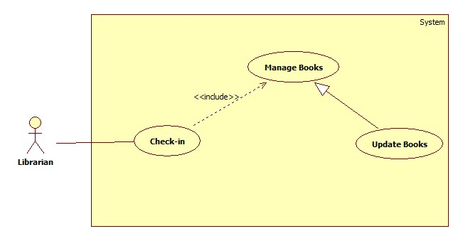

**Figure 2: <Librarian> Update Books**

**Use Case Specification**

|  |  |  |  |
| --- | --- | --- | --- |
| **USE CASE– LAR03** | | | |
| **Use Case No.** | LAR03 | **Use Case Version** | 2.0 |
| **Use Case Name** | Update Books | | |
| **Author** | ThienTT | | |
| **Date** | 24/01/2015 | **Priority** | Normal |
| **Actor:**  - Librarian  **Summary:**  - This use case allows librarian to update information of books.  **Goal:**  - New information of books will be update to database.  **Triggers:**  - At thescreen of librarian works, user click “Update Book” button.  **Preconditions:**  - User must be login to system with role Librarian.  - Screen of librarian works is displayed.  - User chooses Update Book function.  **PostConditions:**   * Success: New information of bookswill beupdated to database and the screen will show message “Book has been updated successful”. * Fail: Information of book won’t be changed and the screen will show message “Update book failed. Please try again”.   **Main Success Scenario:**   |  |  |  | | --- | --- | --- | | Step | Actor Action | System Response | | 1 | Go to screen of librarian works | Display screen of librarian works | | 2 | Click “Update Book” | Display “Update Book” form | | 3 | User input all information of book |  | | 4 | User click “Submit” button | Information will be updated to database and the screen show message “Updated books successful” |   **Alternative Scenario:**  **N/A**  **Exceptions:**   |  |  |  | | --- | --- | --- | | No | Actor Action | System | | 1 |  | Response | |  |  |  | |  |  |  |   **Relationships:**Manage Books  **Business Rules:**  - Thànhphầnmôtảcácyêucầuvềmặtnghiệpvụcủa use case.  - Tấtcảcácgiảđịnhvềnghiệpvụnếucóphảiđượcghivào  - Chúýtớisựchuyểnđổivềtrạngtháicủadữliệucũngphảiđượcghitạiđây  - Cácđịnhnghĩacũngcầnlàmrõ (sảnphẩmnổibật,sảnphẩmsắpcólàsảnphẩmthếnàotronghệthống)  - Cácràngbuộcdữliệudướihệthống, cácrule liênquanđếntoànvẹndữliệu  - Cácqui trình,activities,quátrìnhchuyểnđổitrạngtháicủahệthống | | | |

**2.3.1.2.3 <Librarian>Remove Books**

**Use CaseDiagram**

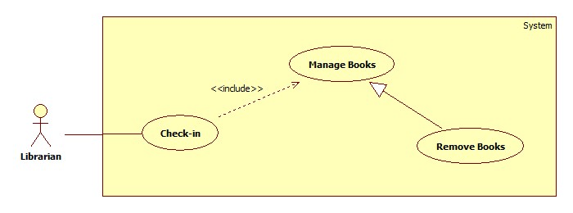

**Figure 2: <Librarian>Remove Books**

**Use Case Specification**

|  |  |  |  |
| --- | --- | --- | --- |
| **USE CASE– LAR04** | | | |
| **Use Case No.** | LAR04 | **Use Case Version** | 2.0 |
| **Use Case Name** | Remove Books | | |
| **Author** | ThienTT | | |
| **Date** | 24/01/2015 | **Priority** | Normal |
| **Actor:**  - Librarian  **Summary:**  - This use case allows librarian to remove books.  **Goal:**  - Book will be removed from database and not exist in system.  **Triggers:**  - At the View List Book, user select books and click “Remove” button.  **Preconditions:**  - User must be login to system with role Librarian.  - List books are displayed.  - User chooses Remove Book function.  **PostConditions:**   * Success: Books will be removed from the database and the screen will show message “Removed book successful” * Fail: Bookscannot remove and the screen will show error message “Removed fail. Please check again”.   **Main Success Scenario:**   |  |  |  | | --- | --- | --- | | Step | Actor Action | System Response | | 1 | Go to View List Books | Show list books | | 2 | User select books want to remove book |  | | 3 | User click “Remove Book” button | Book will be removed from database and show message “Removed success” |   **Alternative Scenario:**  **N/A**  **Exceptions:**   |  |  |  | | --- | --- | --- | | No | Actor Action | System | | 1 |  | Response | |  |  |  | |  |  |  |   **Relationships:**Manage Book  **Business Rules:**  - Thànhphầnmôtảcácyêucầuvềmặtnghiệpvụcủa use case.  - Tấtcảcácgiảđịnhvềnghiệpvụnếucóphảiđượcghivào  - Chúýtớisựchuyểnđổivềtrạngtháicủadữliệucũngphảiđượcghitạiđây  - Cácđịnhnghĩacũngcầnlàmrõ (sảnphẩmnổibật,sảnphẩmsắpcólàsảnphẩmthếnàotronghệthống)  - Cácràngbuộcdữliệudướihệthống, cácrule liênquanđếntoànvẹndữliệu  - Cácqui trình,activities,quátrìnhchuyểnđổitrạngtháicủahệthống | | | |

**2.3.1.3 <Librarian> View student information**

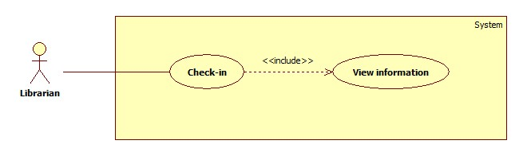

**Figure 2: <Librarian> View student information**

**Use Case Specification**

|  |  |  |  |
| --- | --- | --- | --- |
| **USE CASE– LAR05** | | | |
| **Use Case No.** | LAR05 | **Use Case Version** | 2.0 |
| **Use Case Name** | View Student Information | | |
| **Author** | ThienTT | | |
| **Data** | 27/01/2015 | **Priority** | Normal |
| **Actor:**  - Librarian  **Summary:**  - This use case allows librarian to view student.  **Goal:**  - Information of student will be display on screen.  **Triggers:**  - At the screen of librarian works, user scan the card with the distance is 3cm.  **Preconditions:**  - User must be login to system with role Librarian.  - Librarian’s work screen is displayed.  - User chooses View information function.  **PostConditions:**   * Success: Display all information of student. * Fail: Don’t show information of student and the screen will show message “Cannot view information. Please scan again”   **Main Success Scenario:**   |  |  |  | | --- | --- | --- | | Step | Actor Action | System Response | | 1 | Go to screen of librarian works | Display screen of librarian works | | 2 | Scan the card with distance is 3cm | All information will show |   **Alternative Scenario:**  **N/A**  **Exceptions:**   |  |  |  | | --- | --- | --- | | No | Actor Action | System | | 1 |  | Response | |  |  |  | |  |  |  | | | | |

**2.3.1.4<Librarian> Search Books**

**Use CaseDiagram**

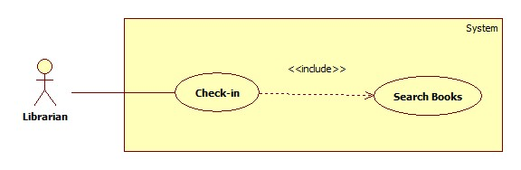

**Figure 2: <Librarian>Search Books**

**Use Case Specification**

|  |  |  |  |
| --- | --- | --- | --- |
| **USE CASE– LAR06** | | | |
| **Use Case No.** | LAR06 | **Use Case Version** | 2.0 |
| **Use Case Name** | Search Books | | |
| **Author** | ThienTT | | |
| **Data** | 27/01/2015 | **Priority** | Normal |
| **Actor:**  - Librarian  **Summary:**  - This use case allows librarian find a book.  **Goal:**  - Information of book will be show.  **Triggers:**  - At the screen of librarian works, user input name of book and press enter or click “Search” button.  **Preconditions:**  - User must be login to system with role Librarian.  - Screen of librarian works is displayed.  - User chooses Search book function.  **PostConditions:**   * Success: Display all information of book. * Fail: Don’t show information of book and the screen will show message “Book not found. Please check again”   **Main Success Scenario:**   |  |  |  | | --- | --- | --- | | Step | Actor Action | System Response | | 1 | Go to screen of librarian works | Display screen of librarian works | | 2 | Input name of book |  | | 3 | Press Enter or click “Search” button | All information of book will show. |   **Alternative Scenario:**  **N/A**  **Exceptions:**   |  |  |  | | --- | --- | --- | | No | Actor Action | System | | 1 |  | Response | |  |  |  | |  |  |  | | | | |

**2.3.1<Borrower>OverviewUseCase**

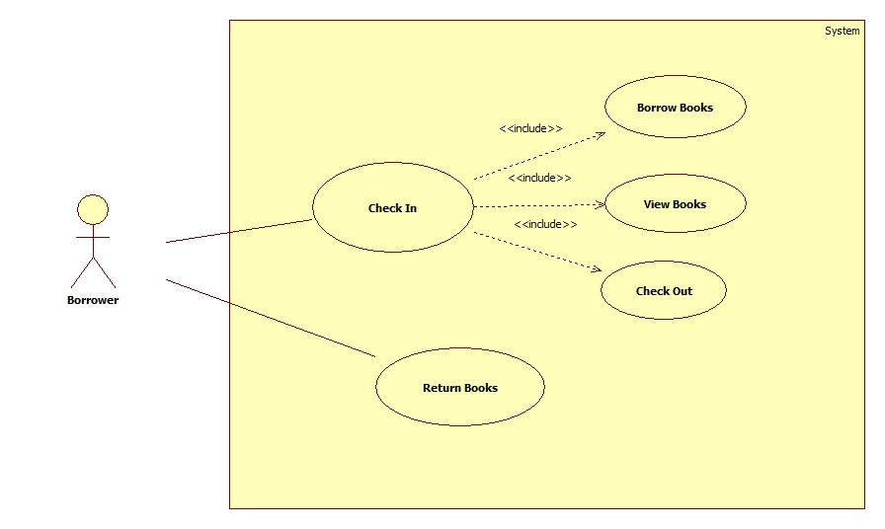

**Figure 1: <Borrower > Overview Use Case**

**2.3.1.1<Borrower >Borrower Return Books**

**Use CaseDiagram**

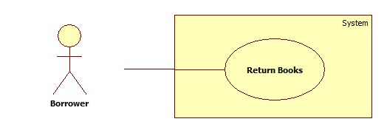

**Figure 2: <Borrower >Borrower Return Books**

**Use Case Specification**

|  |  |  |  |
| --- | --- | --- | --- |
| **USE CASE– LAR01** | | | |
| **Use Case No.** | LAR01 | **Use Case Version** | 2.0 |
| **Use Case Name** | Borrower Return Books | | |
| **Author** | YNX | | |
| **Date** | 24/01/2015 | **Priority** | High |
| **Actor:**  - Borrower  **Summary:**  - This use case allows borrower to return books.  **Goal:**  - Borrower return books successful.  **Triggers:**  - User scan the book with the distance is 3cm.  **Preconditions:**  - User can be librarian or borrower.  **PostConditions:**   * Success: Return is successful. * Fail: Return fail and require user scan the book again.   **Main Success Scenario:**   |  |  |  | | --- | --- | --- | | Step | Actor Action | System Response | | 1 | Scan the book with distance is 3cm | Authentication page is display | | 2 | Click Submit | Display screen success or fail |   **Alternative Scenario:**  **N/A**  **Exceptions:**   |  |  |  | | --- | --- | --- | | No | Actor Action | System | | 1 |  | Response | |  |  |  | |  |  |  |   **Relationships:**Mối quanhệ với các Usecasekhác nếu cótrong quá trình xửlý,tuy nhiên nó khôngphải là abstract usecase  **Business Rules:** | | | |

**2.3.1.2 <Borrower>Check In**

**Use CaseDiagram**

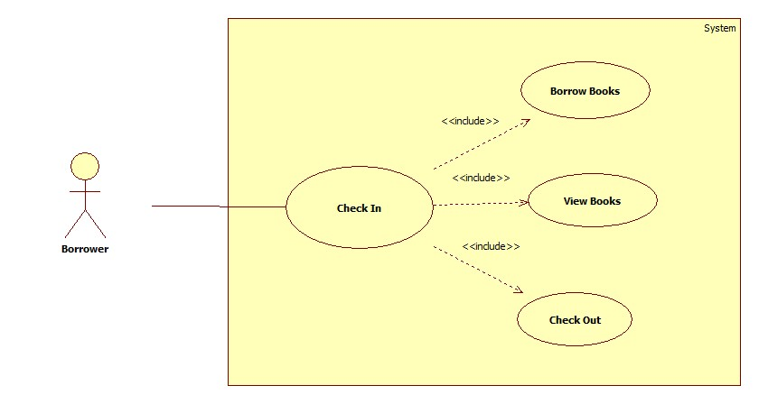

**Figure 2: <Borrower>Check In**

**2.3.1.2.1 <Borrower>Check In**

**Use CaseDiagram**

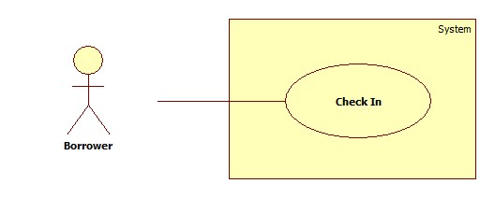

**Figure 2: <Borrower> Check In**

**Use Case Specification**

|  |  |  |  |
| --- | --- | --- | --- |
| **USE CASE– LAR02** | | | |
| **Use Case No.** | LAR02 | **Use Case Version** | 2.0 |
| **Use Case Name** | Borrower Check In | | |
| **Author** | YNX | | |
| **Date** | 24/01/2015 | **Priority** | High |
| **Actor:**  - Borrower  **Summary:**  - This use case allows borrowerto check in the system.  **Goal:**  - Borrower login successful.  **Triggers:**  - At the login page, user scan the card with the distance is 3cm.  **Preconditions:**  - User must be borrower.  - Login page is display.  **PostConditions:**   * Success: Login is successful. * Fail: Login fail and require user scan the card or input PIN again.   **Main Success Scenario:**   |  |  |  | | --- | --- | --- | | Step | Actor Action | System Response | | 1 | Go to Login page | Login page is display | | 2 | Scan the card with distance is 3cm | Authentication page is display | | 3 | User input PIN and click Submit | Display screen of borrower works |   **Alternative Scenario:**  **N/A**  **Exceptions:**   |  |  |  | | --- | --- | --- | | No | Actor Action | System | | 1 |  | Response | |  |  |  | |  |  |  |   **Relationships:**Mối quanhệ với các Usecasekhác nếu cótrong quá trình xửlý,tuy nhiên nó khôngphải là abstract usecase  **Business Rules:** | | | |

**2.3.1.2.2 <Borrower> Borrow Books**

**Use CaseDiagram**

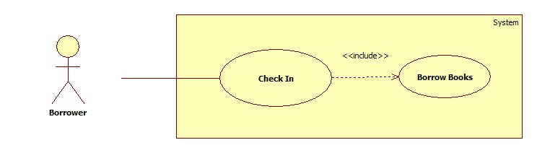

**Figure 2: <Borrower> Borrow Books**

**Use Case Specification**

|  |  |  |  |
| --- | --- | --- | --- |
| **USE CASE– LAR03** | | | |
| **Use Case No.** | LAR03 | **Use Case Version** | 2.0 |
| **Use Case Name** | Borrow Books | | |
| **Author** | YNX | | |
| **Date** | 24/01/2015 | **Priority** | Normal |
| **Actor:**  - Borrower  **Summary:**  - This use case allows borrower to borrow books.  **Goal:**  - Borrower borrow books successful.  **Triggers:**  - At the screen of Borrower works, user click “Borrow Book” button.  **Preconditions:**  - User must be login to system with role Borrower.  - Screen of Borrower works is displayed.  - User chooses Borrow Book function.  **PostConditions:**   * Success: Information of Borrowed books will be updated to database and the screen will show message “Book has been borrowed successful”. * Fail: Borrowed books won’t be changed and the screen will show message “Borrow book failed. Please try again”.   **Main Success Scenario:**   |  |  |  | | --- | --- | --- | | Step | Actor Action | System Response | | 1 | Go to screen of Borrower works | Display screen of Borrower works | | 2 | Click “Borrow Book” | Information will be updated to database and the screen show message “Book has been borrowed successful” |   **Alternative Scenario:**  **N/A**  **Exceptions:**   |  |  |  | | --- | --- | --- | | No | Actor Action | System | | 1 |  | Response | |  |  |  | |  |  |  |   **Relationships:**Mối quanhệ với các Usecasekhác nếu cótrong quá trình xửlý,tuy nhiên nó khôngphải là abstract usecase  **Business Rules:** | | | |

**2.3.1.2.3 <Borrower>View Books**

**Use CaseDiagram**

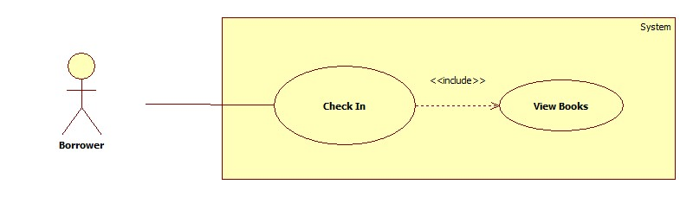

**Figure 2: <Borrower>View Books**

**Use Case Specification**

|  |  |  |  |
| --- | --- | --- | --- |
| **USE CASE– LAR04** | | | |
| **Use Case No.** | LAR04 | **Use Case Version** | 2.0 |
| **Use Case Name** | View Books | | |
| **Author** | YNX | | |
| **Date** | 24/01/2015 | **Priority** | Normal |
| **Actor:**  - Borrower  **Summary:**  - This use case allows Borrowerto view books.  **Goal:**  - User can view number of books user has borrowed.  **Triggers:**  - At the screen of Borrower works, user click “View Book” button.  **Preconditions:**  - User must be login to system with role Borrower.  - User chooses View Book function.  - List books are displayed.  **PostConditions:**   * Success: List books will be displayed. * Fail: List books can not display and the screen will show error message “View books fail. Please try again”.   **Main Success Scenario:**   |  |  |  | | --- | --- | --- | | Step | Actor Action | System Response | | 1 | Go to screen of Borrower works | Display screen of Borrower works | | 2 | Click “View Book” | Show list Books |   **Alternative Scenario:**  **N/A**  **Exceptions:**   |  |  |  | | --- | --- | --- | | No | Actor Action | System | | 1 |  | Response | |  |  |  | |  |  |  |   **Relationships:**Mối quanhệ với các Usecasekhác nếu cótrong quá trình xửlý,tuy nhiên nó khôngphải là abstract usecase  **Business Rules:** | | | |

**2.3.1.2.4<Borrower>Check Out**

**Use CaseDiagram**

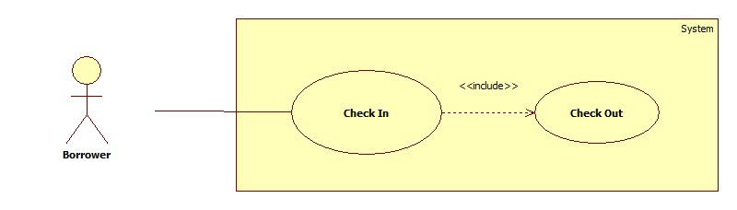

**Figure 2: <Borrower>Check Out**

**Use Case Specification**

|  |  |  |  |
| --- | --- | --- | --- |
| **USE CASE– LAR04** | | | |
| **Use Case No.** | LAR04 | **Use Case Version** | 2.0 |
| **Use Case Name** | Check Out | | |
| **Author** | YNX | | |
| **Date** | 24/01/2015 | **Priority** | Normal |
| **Actor:**  - Borrower  **Summary:**  - This use case allows Borrower to check out.  **Goal:**  - Borrower log out sucessful.  **Triggers:**  - At the screen of Borrower works, user click “Log out” button.  **Preconditions:**  - User must be login to system with role Borrower.  - User chooses Log out function.  **PostConditions:**   * Success: Log out is successful. * Fail: Logout fail and require user try again.   **Main Success Scenario:**   |  |  |  | | --- | --- | --- | | Step | Actor Action | System Response | | 1 | Go to screen of Borrower works | Display screen of Borrower works | | 2 | Click “Log Out” | Show message |   **Alternative Scenario:**  **N/A**  **Exceptions:**   |  |  |  | | --- | --- | --- | | No | Actor Action | System | | 1 |  | Response | |  |  |  | |  |  |  |   **Relationships:**Mối quanhệ với các Usecasekhác nếu cótrong quá trình xửlý,tuy nhiên nó khôngphải là abstract usecase  **Business Rules:** | | | |